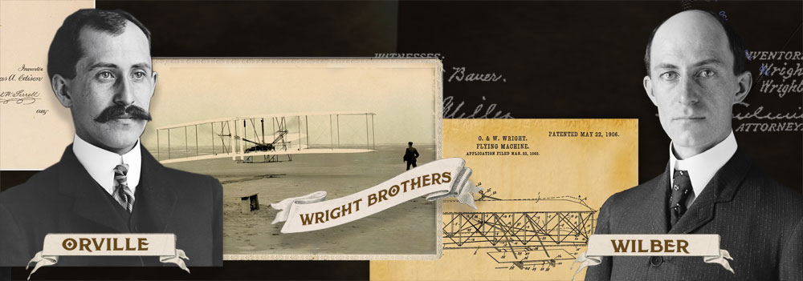

Who are these men?
Lewis and Clark
Orville and Wilbur Wright
John Smith and John Rolfe
Thomas Edison and Albert Einstein

What are they famous for?
Inventing the light bulb
Exploring the Louisiana Purchase
Inventing and flying the first airplane
Establishing a colony in Jamestown, Virginia
What can we learn from these two men?
Some people are lucky, others are not.
If you borrow money, then you can buy yourself a plane.
Airplanes are the best way to travel.
If you work hard, then you can accomplish your goals.

When did Orville Wright become the first man to fly an airplane?
December 17, 1903
December 7, 1903
December 17, 1933
December 7, 1997

Why did the Wright Brothers choose North Carolina to test their airplane?
The inner bank area was the coldest.
It had the prettiest skies.
The outer bank area was the windiest.
It had the warmest climate.

How did Orville and Wilbur's job when they were younger prepare them to fly a plane?
They loved cooking food.
They enjoyed building and fixing things.
They loved to run and exercise.
They enjoyed riding bikes.
How long did Orville and Wilbur Wright’s plane travel on their very first fight?
35 minutes
59 seconds
12 seconds
1 minute

